**UTT/24/0642FUL**

The site is within the Green Belt. The NPPF states “Inappropriate development is, by definition, harmful to the Green Belt and should not be approved except in very special circumstances.” This application fails to prove very special circumstances.

This is also backland development in that the proposed properties do not front onto a road and is therefore, contrary to the Uttlesford Local plan. Additionally, it is outside the village development limits and is contrary to the Parish Plan.

The development would adversely impact the rural aspect of Birchanger village.

Proposed access is across two PROW footpaths 15 & 16. It also includes an access road onto footpath 16. This would involve using part of the Birchanger village green.

The village green is registered as such and owned by the Parish Council and it can be seen, from the map obtained from Essex County Council Register of Green and Common Land, that our village green stretches from the boundary of Old Cottage, 274 Birchanger Lane, across the entrance to footpath 16 and on to the boundary of 266 Birchanger Lane. Under no circumstances will the Parish Council give permission for the village green to be used to form an access route onto this proposed development.

The two included attachments refer to the ownership and location of the village green:

1. Letter from the Commons Commissioner dated 6 February 1981 regarding the ownership of the village green.
2. Map showing the location of the village green.

Widening and clearing the footpaths would destroy trees and hedgerows and would affect biodiversity and protected species. Indeed hedgehogs, which are a legally protected species, have been identified on footpath15, so using this footpath as an access point would have a detrimental effect.

The Landscape & Visual Assessment P52 states “Generally the area has views of limited value and footpaths are not well used by the wider public”. However, our footpaths are frequently used by cyclists and walkers, very often with dogs and small children. Many users are not local residents but use the footpaths as a safe recreational walk in the Green Belt. This right would be destroyed by allowing the paths to be altered to made up roads to be used by vehicles to service backland development and in so doing severely affect the amenity of residents and visitors. Indeed, the Pre-Application advice states “It must be noted that all three potential accesses are coinciding with PROW routes and any development at that location will significantly impact those routes.”

Access solely for unit 1 is suggested along footpath 15 which runs very close to a grade II listed building at 228 Birchanger Lane and would exit onto a bend in Birchanger Lane with little visibility. Using this footpath as an access route would not only have a detrimental effect on this listed property but also on the lives of those living there.

The Pre-Application Report from the Planning Inspectorate states the Inspector visited the site on April 18, 2023, and noted that traffic on the Lane was “light”. At this time Birchanger Lane was closed to through traffic and did not open until July 2023. Surveys have taken place which show that traffic has increased by 200% in recent years so any additional roads leading into the lane, particularly on a bend or where the lane is narrow, which would be the case for both suggested footpaths, would be dangerous.

This Pre-Application Report also refers to the UDC 5-year land supply. The report refers to UDC Housing Land Supply in 2022 when they had 4.89 years supply. However, the. UDC 2023 HLS states 5.14 years so these proposed 9 houses are not needed to satisfy the requirement. Indeed, in the NPPF of December 2023 states, Local Plans at examination, Regulation 18 or Regulation 19 stage, with a policy map and proposed allocations towards meeting housing need, only has to demonstrate a four-year housing land supply (as opposed to five years) for a period of two years for decision making purposes.

The application form is incorrect. Under Assessment of Flood Risk, the applicant has answered “No” to the question “Is your proposal within 20 meters of a river, stream or beck”. However, the answer is emphatically “Yes” as there is a ditch which runs along the front of the site, just below the surrounding fence, which is fed by an underground spring. The stream in this ditch has, on occasions, almost burst the banks during periods of heavy rain. See photo below:

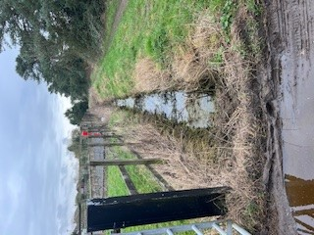

Every year at our Annual Village meeting the following motion is passed unanimously:

**This meeting rejects any further coalescence with neighbouring towns and villages and will endeavour to protect the remaining Green Belt surrounding the village.**

Uttlesford District Council covers approximately 250 sq miles only 6% of which is Green Belt. The approval of this application would set a precedent and could open the flood gates for other planning applications on the Green Belt

The applicant’s previous application in 2014 for one house was turned down both by UDC and then on appeal for several reasons including that it was in the Green Belt, was backland development and there were access issues. Nothing has changed and therefore, the application should be refused.

**Birchanger Parish Council**

Attachment (a): Letter from the Commons Commissioner.

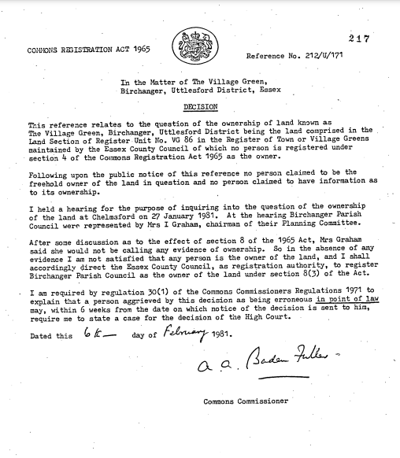

Attachment (b): Map showing the Birchanger Village Green. (Source: Essex County Council Register of Green and Common Land)

